Asia Economic Community
2020 Model Asia Union Application

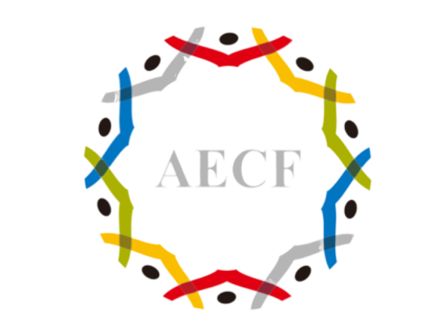
Model Asia Union(MAU) held by Asia Economic Community every year is an opportunity where young adults from around the world can discuss and share opinions of their own regarding the crisis and issues within and out of Asia. This program is a part of Asia Economic Community Forum(AECF) where prominent experts on Asian economy around the world gather to study and conduct in depth research on the future of Asia. This year’s topic for both AECF and MAU will be ‘Northeast Asia and the Asian Community in the Age of Hyper-Uncertainty’. As this is the most valid and timely issue that should be dealt, MAU and AECF 2020 will be more than great experience for all students interested in the present and future of Asia.

AECF / MAU 2020 will be held on the first week of November (11/6) in Incheon Sheraton Hotel if COVID-19 situation allows.

Name
Date of Birth
Contact information
(E-mail, Instagram or Facebook account available)
University and major / Job

